**AddressIQ API - Single Address Standardization - Postman Testing Steps**

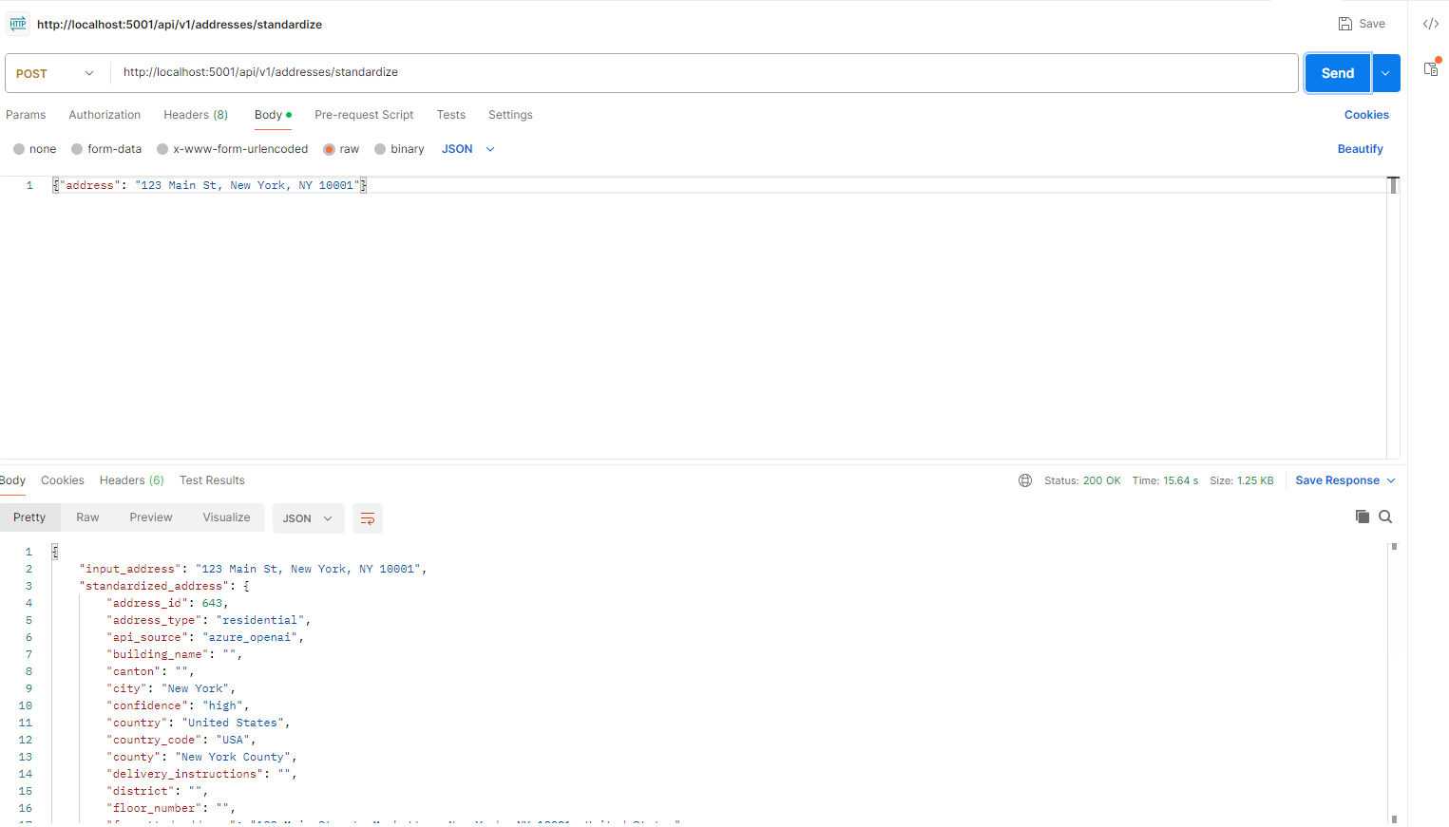  
  
(Paste your screenshot image here when you open this in Word)

**STEP 1: Open Postman**

* Launch Postman application
* Create a new request

**STEP 2: Configure Request Method**

* Set Method to: **POST**
* **← In screenshot: Method dropdown set to "POST" (USER FILLS THIS)**

**STEP 3: Enter API URL**

* Enter URL: http://localhost:5001/api/v1/addresses/standardize
* **← In screenshot: URL bar with the API endpoint (USER FILLS THIS)**

**STEP 4: Configure Request Headers**

* Click on "Headers" tab
* Add header: **Content-Type** = **application/json**
* **← In screenshot: Headers tab with Content-Type header (USER ADDS THIS)**

**STEP 5: Configure Request Body**

* Click on "Body" tab
* Select "raw" option
* Select "JSON" from dropdown
* **← In screenshot: Body tab with "raw" and "JSON" selected (USER SELECTS THIS)**
* Enter the JSON payload:

{ "address": "123 Main St, New York, NY 10001" }

**← In screenshot: JSON payload in body area (USER TYPES THIS)**

**STEP 6: Send Request**

* Click the blue **"Send"** button
* Wait for processing (typically 2-5 seconds)
* **← In screenshot: Status "200 OK" and response data (SHOWS SUCCESS)**

**STEP 7: Review Response**

* Check response contains standardized address components
* Verify latitude and longitude coordinates are included
* Note the confidence score for address validation
* **← In screenshot: Response body with address components (PROCESSED RESULT)**

**SUCCESS INDICATORS:**

* Status: **200 OK** (shown in screenshot)
* Response contains standardized address components
* Latitude and longitude coordinates provided
* Confidence score between 0.0 and 1.0
* Processing time typically 2-5 seconds

**TROUBLESHOOTING:**

* If you get "400 Bad Request" error → Check JSON format and Content-Type header
* If you get "401 Unauthorized" error → Add X-API-Key header if API key is required
* If you get connection error → Make sure server is running on localhost:5001
* If processing fails → Ensure address string is not empty and reasonably formatted

**That's it! Your address will be standardized and returned with detailed components and coordinates.**